St Mary’s CLW Rota Online
https://stm.clwrota.com
This site is available using any browser via any computer or Smartphone from anywhere with internet access. A smart phone optimized version of the site is also accessible from the mobile sites below:

Mobile site https://stm.clwrota.com/mrota/
This site is an optimized version of the for smart phones
Iphone app http://clwrota.com/iphone
This site will tell you more about the iPhone app. Many of the rota’s features are available via this app however the mobile site is more reliable.

Passwords
Anaesthetists have been allocated their own access username and passwords.
If you have any problems please contact marysrotatyrant@gmail.com
Once logged in you can see your planned timetable for the week. It is also a useful page to check a few weeks ahead, on calls and all forms of leave.
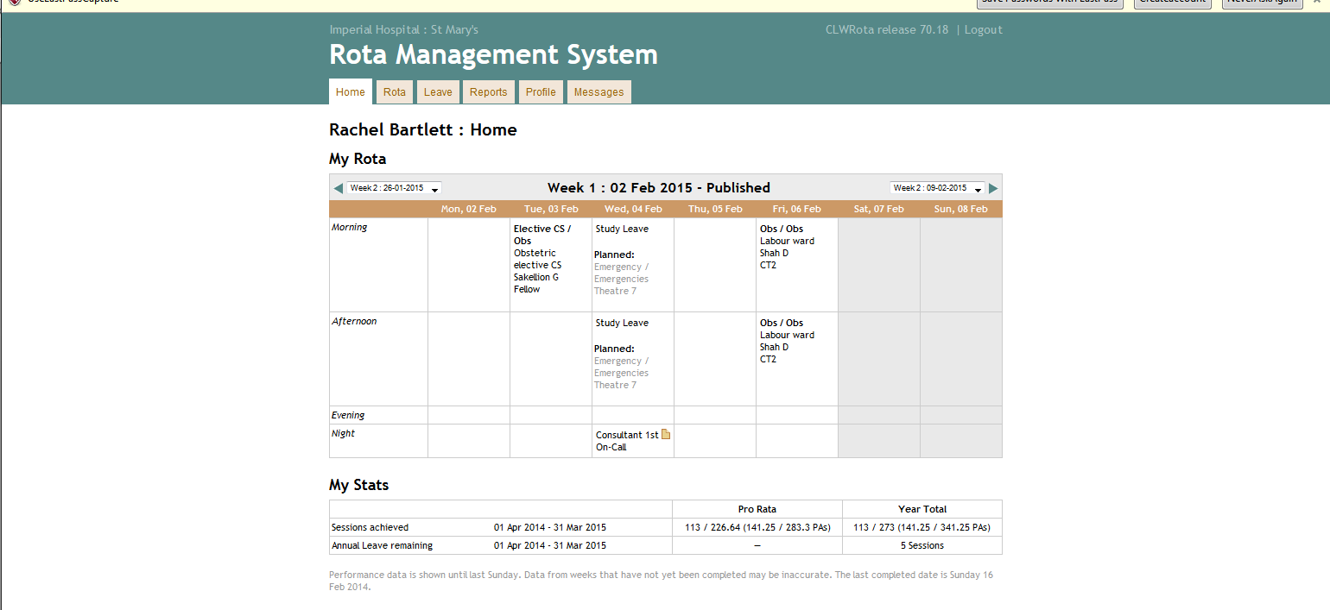
Displaying the weekly rota
There are several ways to display the weekly rota; by person, location, on calls etc.
The most commonly used is by location. Select Rota > Locations > Theatres or ALL locations
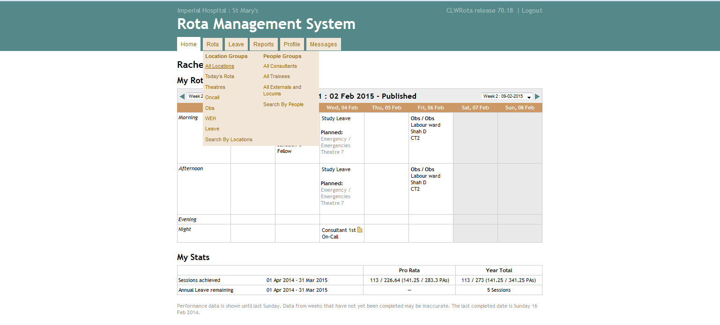

You will notice various lists have highlighted boxes or additional keys. They mean anything from a solo trainee (yellow), uncovered by anaesthetist (red) etc
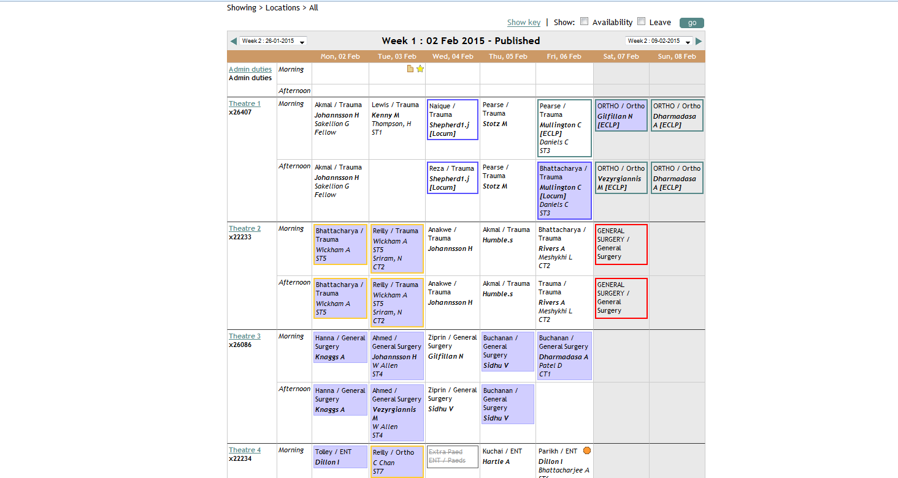

Please do note there is a trainee back-up for obstetrics. Scroll down near the on call section. The 1201 consultant is labelled as Theatre 8 because they cover trauma. This is your mentor in the absence of anyone else.
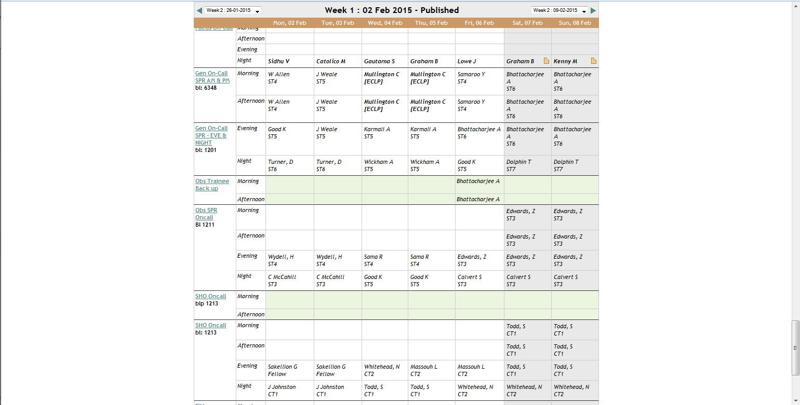

You cannot print out a copy of the whole rota easily because it is designed that changes are checked on line only. Any changes from the original published rota appear shaded. Often you will receive a text if any changes have occurred on your rota e.g. list location etc.
On calls
You can find out who is on call by the weekly rota above OR by getting a list of names at Reports > Group on call report. Select the start date desired in search and the particular group e.g. trainees.

Duty leave
To make the rota compliant there are duty leave days built into the rota. These days are associated with the on calls and SHOULD NOT be swapped. Some on call swaps will carry duty leave swaps too. All original shifts need to be covered.

